Câu 2
(4 Point) You have main function which is saved on folder named Q2 already. Use these classes and function to test all your operations in this question, DO NOT EDIT ANY CODE in main. You can add more operations/classes/interfaces to be able to answer the below questions.
We had provided you:
1. Interface – ICourse which will declare some operations for a Course – DO NOT EDIT this one.
2. You only need to complete the code in class MyCourse and Course.
Design and code a class named Course that holds information about a Course. Information of a Course includes:
- A double value holding fee of a Course.
    - A string describing name of a Course.
Include the following member functions in your design:
- Constructors to set values for instance variables.
- Add needed operations to the class so that the main function can be run and complete the function
  - String getName() – return name of a Course.
Design and code a class named MyCourse which will implement interface ICourse and complete 2 methods which were declared in ICourse
- void f1(List<Course> a, int st) – Sort the list of courses "a" ascending by course fee if st = 1
otherwise move all of course (int the same order as original list) in the list ”a” which have fee is less than or equals 120
- int f2(List<Course> a, double fee) - count and return numbers of courses in the list “a” which are in the list “a” and has course fee greater than or equals given fee.

Given some data which is added to list “a” in the Main already:

Course name | Course fee
PRJ311 | 110
DBI202 | 150
PRF192 | 120

By using given data, the program output might look something like:

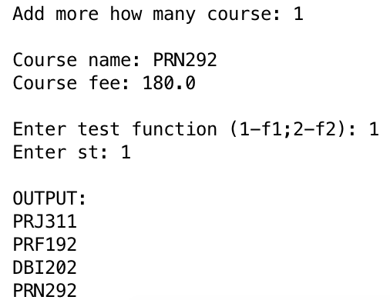 | Add more how many course: 1  Course name: PRN292  Course fee: 180.0  Enter test function (1-f1;2-f2): 1  Enter st: 2  OUTPUT:  DBI202  PRN292
